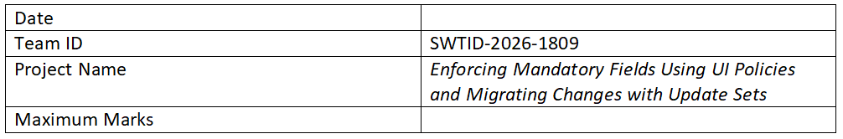

Ideation Phase

Brainstorm & Idea Prioritization Template
Project Name: Enforcing Mandatory Fields Using UI Policies and Migrating Changes with Update Sets
Maximum Marks: 4 Marks

Step-1: Team Gathering, Collaboration and Select the Problem Statement
Problem Statement:
In many systems, important data fields are often left empty or incorrectly filled, leading to data inconsistency and errors. There is also difficulty in safely migrating configuration changes from one environment to another. The goal is to enforce mandatory fields using UI Policies and ensure smooth migration of changes using Update Sets.

Step-2: Brainstorm, Idea Listing and Grouping
Ideas Generated:
- Use UI Policies to enforce mandatory fields dynamically
- Implement client-side validation for better user experience
- Use Update Sets to track and migrate changes
- Maintain separate environments (Development, Testing, Production)
- Automate validation before submitting forms
- Create logs for tracking changes and errors
Grouping:
1. Data Validation: UI Policies, mandatory fields
2. User Experience: Client-side validation, alerts
3. Migration: Update Sets, environment management
4. Monitoring: Logs, error tracking

Step-3: Idea Prioritization
Top Prioritized Ideas:
1. Enforcing mandatory fields using UI Policies
2. Using Update Sets for migration
3. Client-side validation for immediate feedback
4. Maintaining proper environment structure
Reason:
These ideas ensure data accuracy, reduce errors, improve user experience, and provide a reliable way to migrate changes across environments.

